Using Knowledge for Registering Images of Different Modalities
Prof. Jean Sequeira, CEO of the 2IK Company
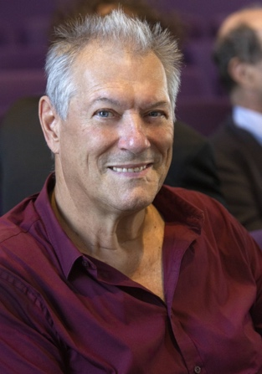
Biography
Prof. Jean Sequeira has been the CEO of 2IK (Image, Information & Knowledge) company since 2017 and an “Invited Professor” since 2008 at the IRSA (Institute for Remote Sensing Applications – institute of the Chinese Academy of Sciences). Formerly, he had been a research project leader at the IBM France company (1981-1991) and a Full Professor at the Aix-Marseille Université from 1991 to 2021 (Exceptional Class Professor since 2010). He used to work in foreign countries (two years in Ivory Coast and six months in United States) or in collaboration with various countries as China, Algeria, Peru, India, Burkina Faso, Canada. He also developed research partnerships with several industrial companies. In 2006, he participated to the creation of an international organization, ISDE (International Society for Digital Earth) and he had been a member of its Executive Committee for ten years (2006-2016). He is the author of about 135 papers and he supervised about 30 PhD students.
During the last 45 years, Prof. Jean Sequeira has been developing research and projects (with institutes and industrials) in the field of “Image and Computer Science”, i.e. “Image Analysis”, “Geometrical Modeling”, “Visualization and Immersive Interaction”, “Pattern Recognition”, “Artificial Intelligence”, for applications dedicated to “Medical Imaging”, “Remote Sensing”, “Forensics”, “Industrial Computer Vision”, “Video Watching” and “Sport Supervision”. Since he retired from his position of Professor at the University in 2021, Jean Sequeira has been developing a Research and Development activity on behalf of the 2IK company, through several partnerships with industrials and academics.
For more information see www.2ik.fr
Abstract
Image registration plays an important role for efficiently integrating information from remote sensing images in a data base. It requires to characterize a set of landmarks we can identify in both images, in order to precisely compute the corresponding geometric transformation. Several algorithms have been designed during the last decades when images are from the same modality. These algorithms are based on identifying the same pieces of information in both images and they provide excellent results.
The problem is much more complex when modalities are different (e.g. multispectral and SAR images, or a map and a panchromatic image). This will lead us to discuss about the respective roles of Information and Knowledge, pieces of Information and Contextual Information, Semantic Knowledge and Machine Learning in the frame of an Artificial Intelligence scheme. As an illustration of these concepts, we will describe a robust algorithm that has been designed for registering two images of different modalities.

