Title

From Code to Coders: Towards Secure and Reliable Software Systems

Abstract
Technology today rarely exists without a software component or interface as more and more systems are being software operated. However, incidents of software failures and vulnerabilities repeatedly make news headlines since the emergence of software to date. In 2017 alone, almost $1.7 trillion in assets, and 3.7 billion people were affected by software failures. The estimated cost of poor software quality in the US has grown to at least $2.41 trillion in 2022.
In this speech, Minhaz Zibran will present part of his research for software assurance – secure and reliable software systems. Minhaz’s research proactively fights software bugs and security vulnerabilities using program code analysis and manipulation while also considering the human factors that affect software quality.
In his talk, Minhaz will first illustrate with an example, how static code analysis and manipulation can be applied to extract interesting aspects of source code. Minhaz will demonstrate the application of static code analysis in detecting patterns of buggy code. Because a vast majority of the software bugs and vulnerabilities are the results of human mistakes in different stages of software development, the third part of Minhaz’s talk will introduce his research for incorporating human aspects in software engineering.

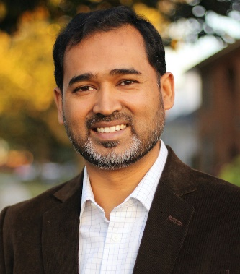
Assoc. Prof. Minhaz F. Zibran, Idaho State University (ISU), USA
Biography
Minhaz F. Zibran is an Associate Professor of Computer Science (CS) at the Idaho State University (ISU), USA. He earned PhD in CS in 2014 from the University of Saskatchewan, Canada.

His funded research in software engineering and cybersecurity fights software bugs and security vulnerabilities using program code analysis and manipulation while also considering the human factors that affect software quality. Minhaz has co-authored many scholarly articles (including a keynote paper) published in ACM and IEEE co-sponsored international conferences and reputed journals. His conference/workshop publications resulted in several best paper awards and journal invitations.

Minhaz also has experience working in the software industry in Canada and Bangladesh. Before joining ISU, he taught at several universities in the US, Canada, and Bangladesh.

Minhaz served on the grant proposal review panels of the US National Science Foundation (NSF) and the Natural Science and Engineering Research Council of Canada. He has been actively involved in organizing international conferences (e.g., MSR, ICDF2C, IWSC, SEMotion, AffectRE, ICPC, ICSM, SCAM) and in reviewing manuscripts submitted to reputed journals (e.g., IEEE Software, IEEE Security & Privacy, TOSEM, EMSE, JSS, IST, SQJ).

References/Papers Related to the Presentation

- Md Rakibul Islam and Minhaz F. Zibran. What Changes in Where? An Empirical Study of Bug-Fixing Change Patterns. ACM Applied Computing Review, 20 (4): 18 - 34, 2021.

- Md Rakibul Islam and Minhaz F. Zibran. SentiStrength-SE: Exploiting Domain Specificity for Improved Sentiment Analysis in Software Engineering Text. Elsevier Journal of Systems and Software (JSS), 145: 125-146, 2018.

- Md Rakibul Islam and Minhaz F. Zibran. Exploration and Exploitation of Developers' Sentimental Variations in Software Engineering. International Journal of Software Innovation, 4 (4): 35 - 55, 2016.

- Minhaz F. Zibran and Chanchal K. Roy. IDE-based Real-time Focused Search for Near-miss Clones. In proceedings of the 27th ACM Symposium On Applied Computing (ACM SAC 2012, Software Engineering Track), pp. 1235 - 1242, Riva del Garda, Trento, Italy, 2012.

