**Architectures of Next Generation Wireless Networks**

**Prof. Pascal Lorenz, University of Haute-Alsace, France, France**

Abstract:

Internet Quality of Service (QoS) mechanisms are expected to enable wide spread use of real time services. New standards and new communication architectures allowing guaranteed QoS services are now developed. We will cover the issues of QoS provisioning in heterogeneous networks, Internet access over 5G networks and discusses most emerging technologies in the area of networks and telecommunications such as IoT, SDN, Edge Computing and MEC networking. We will also present routing, security, baseline architectures of the inter-networking protocols and end-to-end traffic management issues.

Biography: 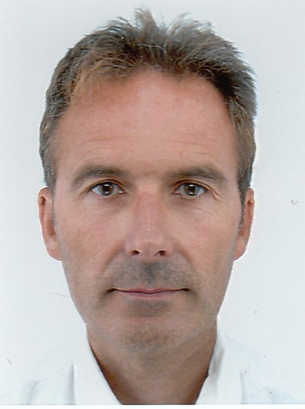

Pascal Lorenz (lorenz@ieee.org) received his M.Sc. (1990) and Ph.D. (1994) from the University of Nancy, France. Between 1990 and 1995 he was a research engineer at WorldFIP Europe and at Alcatel-Alsthom. He is a professor at the University of Haute-Alsace, France, since 1995. His research interests include QoS, wireless networks and high-speed networks. He is the author/co-author of 3 books, 3 patents and 200 international publications in refereed journals and conferences. He was Technical Editor of the IEEE Communications Magazine Editorial Board (2000-2006), IEEE Networks Magazine since 2015, IEEE Transactions on Vehicular Technology since 2017, Chair of IEEE ComSoc France (2014-2020), Financial chair of IEEE France (2017-2022), Chair of Vertical Issues in Communication Systems Technical Committee Cluster (2008-2009), Chair of the Communications Systems Integration and Modeling Technical Committee (2003-2009), Chair of the Communications Software Technical Committee (2008-2010) and Chair of the Technical Committee on Information Infrastructure and Networking (2016-2017), Chair of IEEE/ComSoc Satellite and Space Communications Technical (2022-2023), IEEE R8 Finance Committee (2022-2023), IEEE R8 Conference Coordination Committee (2023). He has served as Co-Program Chair of IEEE WCNC'2012 and ICC'2004, Executive Vice-Chair of ICC'2017, TPC Vice Chair of Globecom'2018, Panel sessions co-chair for Globecom'16, tutorial chair of VTC'2013 Spring and WCNC'2010, track chair of PIMRC'2012 and WCNC'2014, symposium Co-Chair at Globecom 2007-2011, Globecom'2019, ICC 2008-2010, ICC'2014 and '2016. He has served as Co-Guest Editor for special issues of IEEE Communications Magazine, Networks Magazine, Wireless Communications Magazine, Telecommunications Systems and LNCS. He is associate Editor for International Journal of Communication Systems (IJCS-Wiley), Journal on Security and Communication Networks (SCN-Wiley) and International Journal of Business Data Communications and Networking, Journal of Network and Computer Applications (JNCA-Elsevier). He is senior member of the IEEE, IARIA fellow and member of many international program committees. He has organized many conferences, chaired several technical sessions and gave tutorials at major international conferences. He was IEEE ComSoc Distinguished Lecturer Tour during 2013-2014.